4.31: Take the 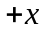-direction to be along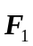 and the 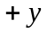-direction to be along 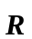. Then 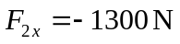 and 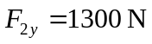, so 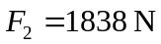, at an angle of 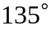 from .

